
Atos for internal use

DHC Quarterly Access Review Report for QX 202X
author(s) : Pawel Osial
version : 1.0
status : Final
source : Atos
document date : 20 June 2022

number of pages : 11
owner : Radoslaw Klicki

© Copyright 2022, Atos IT Services Sp. z o.o. All rights reserved. Reproduction in whole or in part is prohibited without the prior written consent of the copyright owner. For any questions or remarks on this document, please contact Atos, +48501366794.

Contents
1 Purpose 4
2 Scope 5
3 Data input – exports 6
3.1 vRA data export 6
3.2 Management AD data export 6
4 Access Review 7
4.1 Prerequisites 7
4.2 Upload errors 7
4.3 Access review by line managers 7
4.4 Non-user accounts review 9
5 Post-review activities 10

List of changes
version | Date | Description | Author(s)
1.0 | 20/06/2022 | Template creation | Pawel Osial

Purpose
The purpose of this report is to have quarterly access reviews documented. Quarterly access reviews are set to meet CSA/ITCF requirements and cover specifically: LS-08, and LS-09. Additionally, access review in DHC is extended to cover service and non-user accounts.

Scope
The scope of this documented access review is:

Term: | QX 202X
Environment(s): | XXXXXXX
Domain(s): | vRA, Management AD
Access Review tool: | N3View

Data input – exports
Following data exports were provided by the DevSecOps team as input data for the access review.

vRA data export
Attach file

Management AD data export

Attach file

Access Review
To execute access reviews in DHC Management domain, an internal Atos FR tool is in use – N3View. The tool is accessible for all Atos employees and can be accessed through the SSO/PKI. There are two templates for input data, that can be uploaded to the tool with reference to users in LDAP (NESSIE) by DAS ID or Email. This functionality allows us to review accesses for vRA accounts where users have only email addresses and AD accounts where users have DAS IDs. Accounts not discovered by the tool during the upload, and not included in the review due to the error message: "Manager not found in database and LDAP(...)" are considered as employees who already left Atos and those accounts are being removed.

Prerequisites
Since the excel based export files were not meeting exact N3View upload templates requirements, data export files were transformed into these input files:

vRA:
Attach file

AD Management:
Attach file

Upload errors
All items with upload errors are considered as employees who already have left Atos, Service Accounts, API accounts, or any other non-user accounts. User-related accounts were sent for revocation and all the others were sent for manual review by the DevSecOps team.

Management AD upload errors:
Management AD upload errors indicated removal of the following accounts:
- XXXX

Attach file

vRA upload errors:
vRA upload errors indicated removal of the following accounts:
- XXXX

Attach file

Access review by line managers

Management AD
User accounts in the Management AD were reviewed by the line managers from the 10th of May 2022 till the 31st of May 2022.

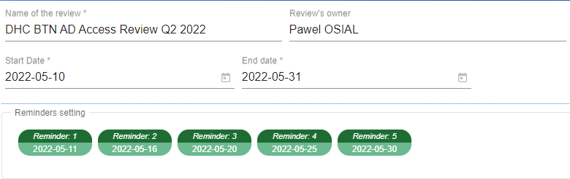

Achieved 100% responses from managers covering all accounts.
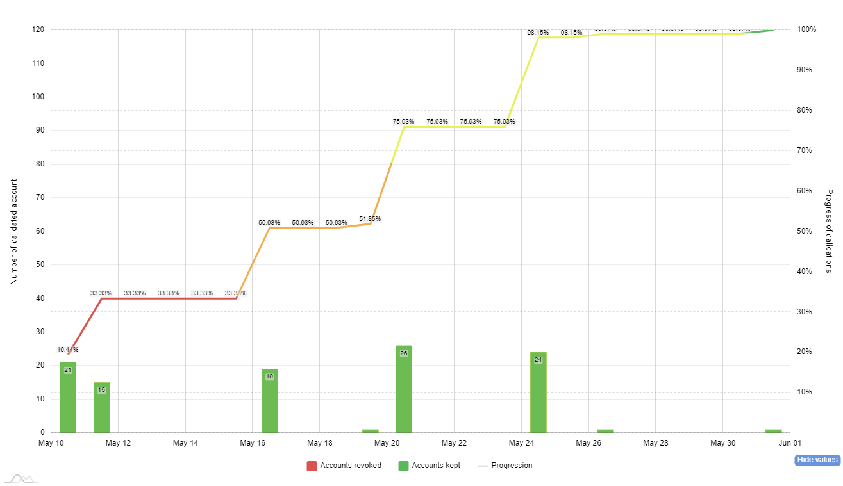

Review result
- XXX% keep
- XXX% revoke

Attach file

vRA
User accounts in the vRA were reviewed by the line managers from the 13th of May 2022 till the 31st of May 2022.

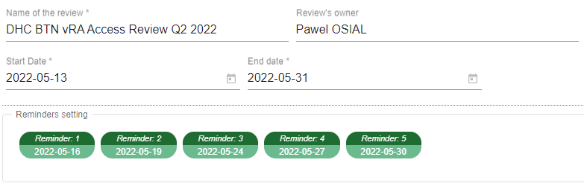

Achieved 100% responses from managers covering all accounts.

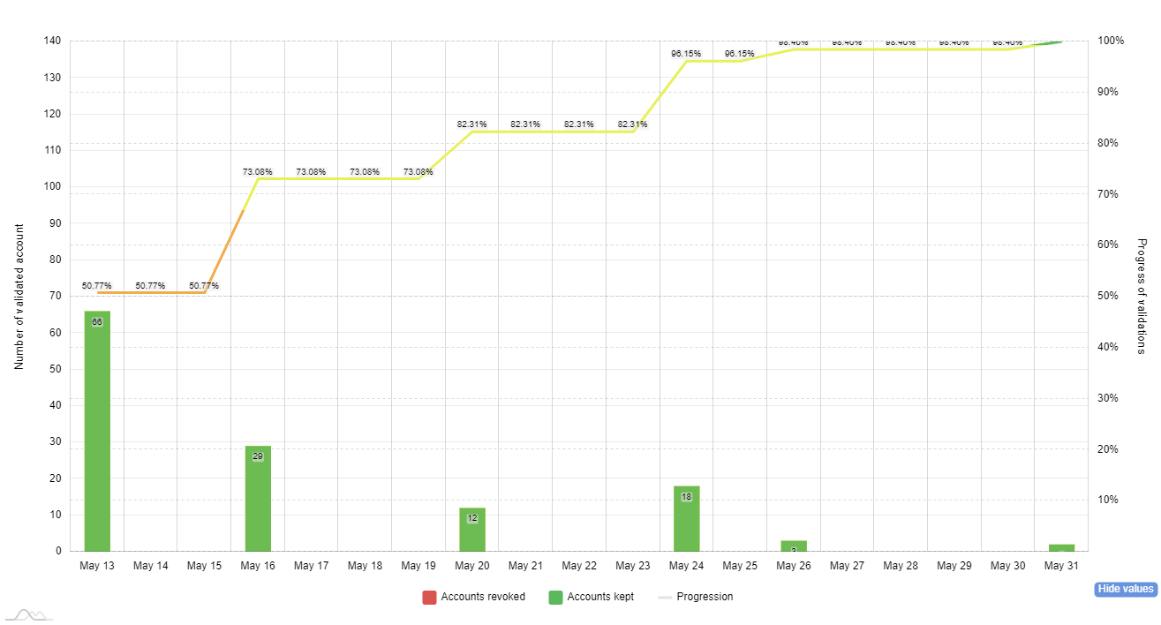

Review result
- XXX% keep
- XXX% revoke

Attach file

Non-user accounts review
A JIRA ticket XXXXX for the DevSecOps team was opened to perform access review for the non-user accounts (mostly service accounts or API accounts) and to perform post-review activities.
Jira ticket:
Attach file (print jira ticket from the browser into pdf file)

Review result
As a result of the team’s access review of the non-user accounts, two accounts were removed:
- XXXX
- XXXX

Post-review activities
All activities related to access amendments as a result of this quarterly access review were implemented and documented under these tickets available in SNOW Global:
- XXXXX

In total X accounts have been removed:
- XXXXX

vRA refers to all the sub-tenants within the master tenant of a particular DHC environment and all their users
Management AD refers to the Active Directory in the Management Domain of the DHC platform
Work on data exports development to meet exact N3View requirements are in progress for Q3 2022 access review

